1. Extract PHP.rar on “C:\” (root of drive).
2. Extract dokuwiki.rar on “saman_solution” folder. Like “C:\inetpub\wwwroot\saman_solution\”
3. Enable FastCGI :
4. Run “Server Manager”
5. Select “Add roles and features”
6. Click “Next” three time
7. Select “CGI“ to installed in it is not.
8. 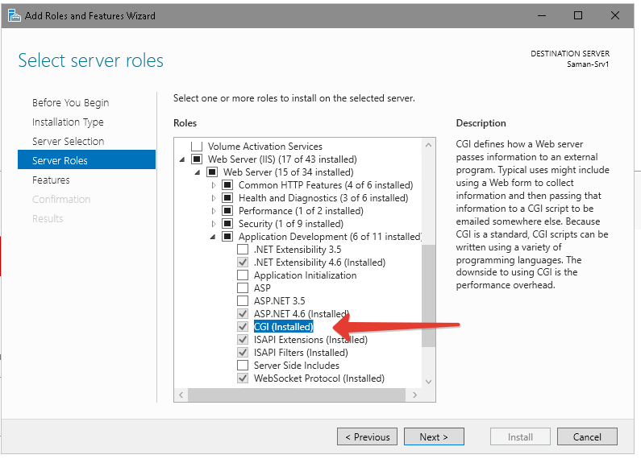
9. Click “Next” and “Install”
10. Config PHP: Edit file c:\PHP\php.ini and set blow…
11. Set “open_basedir” to your location.
12. 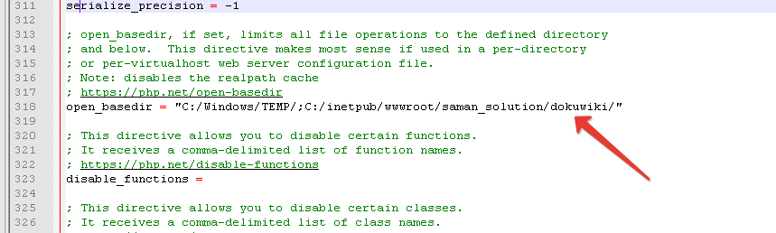
13. Configure IIS to Handle PHP Requests:
14. Open IIS Manager. At the server level, double-click Handler Mappings.
15. In the Actions pane, click Add Module Mapping. In the Add Module Mapping dialog box, specify the configuration settings as follows:

Request path: *.php

Module: FastCgiModule

Executable: "C:[Path to your PHP installation]\php-cgi.exe"

Name: PHP via FastCGI

1. Click OK and then Yes
2. Configure FastCGI recycling settings by using IIS Manager
3. Ensure that the Administration Pack for IIS is installed on your server. if IIS 5 or IIS 6
4. Open IIS Manager. On the server level, double-click FastCGI Settings.
5. Select the FastCGI application that you want to configure. In the Actions pane, click Edit.
6. In the Edit FastCGI Application dialog box, set the InstanceMaxRequests to 10000. Next to the EnvironmentVariables setting, click the Browse (...) button.
7. In the EnvironmentVariables Collection Editor dialog box, add the PHP_FCGI_MAX_REQUESTS environment variable and set its value to 10000.
8. Add DokuWiki site with IIS
9. Open “IIS Manager”
10. Add website :
11. 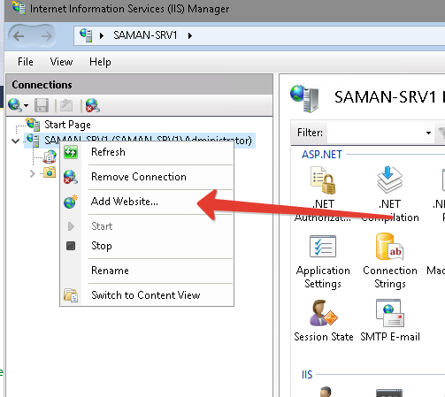
12. Set parameters
13. 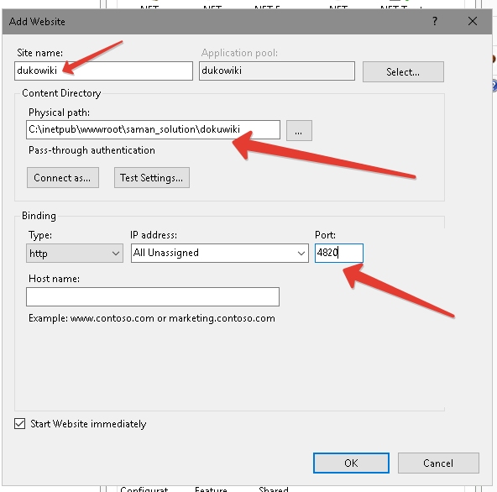
14. Set Secure of directories:
15. In IIS Manager left click the site name
16. Click “Edit Permissions” in the Actions pane OR right click and choose “Edit Permissions” from the shortcut menu.
17. Click the Security tab
18. Click the Edit button
19. Click the Add button
20. Click the Locations button and choose the local server name
21. Now type in IUSR and click OK
22. Set “Write” permission for below folders:
23. 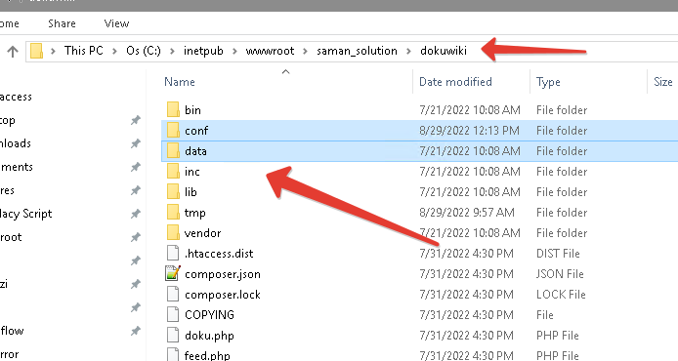

**check this** [**https://www.dokuwiki.org/security**](https://www.dokuwiki.org/security)

**There are two users for each municipality. For example :**

1. **For link from saman: “karaj”**
2. **For administration dokuwiki: “admin.karaj”**
3. **Password is “We10006016”**

**And one saman administration user:**

**User: root**

**Pass: equal with saman!**

**The END**